

**Contacts:**

Michelle Sparacio Ben Arens

Weil-McLain L.C. Williams & Associates

312-485-3749 312-565-4626

[msparacio@weil-mclain.com](mailto:msparacio@weil-mclain.com) [barens@lcwa.com](mailto:barens@lcwa.com)

**Weil-McLain ProTools™ App Now Features Real-Time Video Tech**

**Support to Help Guide Contractors on the Job Site**

Burr Ridge, Ill. – (December 8, 2022) – Just in time for heating season, [Weil-McLain®](https://www.weil-mclain.com/?utm_source=wm+protools+app+enhanced+features+press+release+2022+lcwa&utm_medium=email&utm_campaign=wm+protools+app+enhanced+features+press+release+2022+lcwa) has updated its [ProTools™ App](https://www.weil-mclain.com/protools?utm_source=wm+protools+app+enhanced+features+press+release+2022+lcwa&utm_medium=email&utm_campaign=wm+protools+app+enhanced+features+press+release+2022+lcwa) with enhanced features to provide contractors and service technicians with the support they need to streamline customer visits and provide clients with a premium experience. Available for iOS and Android devices, the app now allows heating professionals to work virtually with Weil-McLain’s Tech Support team to problem-solve issues as they occur on the job site.

“Our goal is to continuously optimize this platform by adding additional features that make service technicians’ and installing contractors’ jobs easier – especially during the busy heating season period,” said David DeVries, Director of Product Management with Weil-McLain. “The new Site-Call video assistance opens new opportunities for service technicians to receive instant support from our Tech Support team.”

Service technicians who run into complications while on the job can contact Weil-McLain Tech Support for Site-Call video and receive immediate real-time assistance. After requesting support, they simply accept the call from Tech Support on their smartphone and share a live video of the issue they are experiencing on the job site. Tech Support will then highlight the issue on the service technician’s screen and propose corrective action to solve it.

“This new feature provides heating professionals with immediate access to our support team and also allows them the opportunity to learn new methods for troubleshooting, maintenance and boiler setup,” added DeVries. “As we prepare for what could be another colder than normal winter, we want to ensure service technicians have all the digital tools and knowledge they need to help expedite customer visits while providing homeowners a best-in-class service experience.”

The Weil-McLain ProTools App helps enhance service technicians’ hydronic expertise by putting a variety of Weil-McLain boiler product information at their fingertips. From reviewing fault codes for troubleshooting and accessing how-to videos to viewing product manuals and schematics and quickly finding parts, the app has become a one-stop resource for boiler installation and maintenance.

For more information on the upgraded Weil-McLain ProTools App, visit [www.weil-mclain.com](https://www.weil-mclain.com/?utm_source=wm+protools+app+enhanced+features+press+release+2022+lcwa&utm_medium=email&utm_campaign=wm+protools+app+enhanced+features+press+release+2022+lcwa) or download the app via the [App Store](https://apps.apple.com/US/app/id1581864471?mt=8) or [Google Play](https://play.google.com/store/games?hl=en_US&gl=US).

# # #

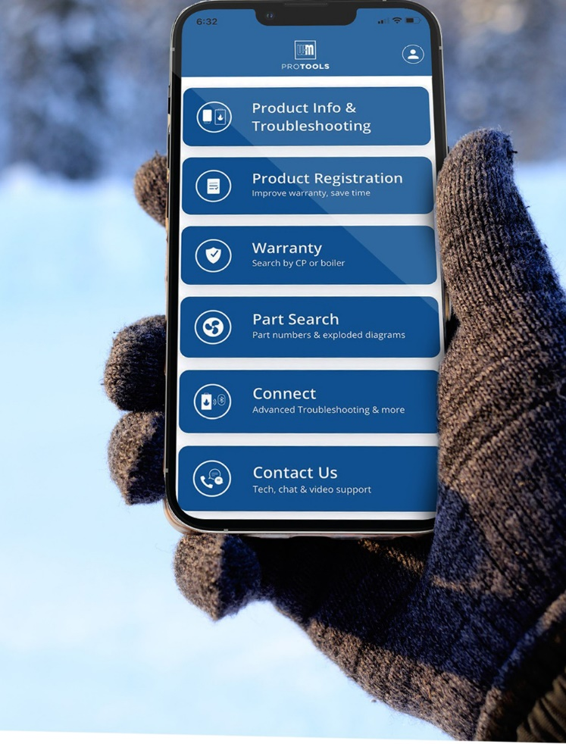

About Weil-McLain

Weil-McLain® is a leading North American Brand of hydronic comfort heating systems for residential, commercial and institutional buildings, since 1881. Contractors, engineers, architects, homeowners and facility managers alike rely on Weil-McLain boilers for their comfort heating needs. Installed in homes, offices, schools, restaurants, hotels and other facilities throughout North America, the Weil-McLain brand is among the most trusted and often used in the building industry.

WM Technologies, LLC, assembles, sells and distributes Weil-McLain boilers, based out of Eden North Carolina. The Marley-Wylain Company, LLC, manufactures and processes traditional Cast Iron products, based out of Michigan City, Indiana. With approximately 600 employees within manufacturing facilities, sales locations across the US, and administrative offices in Burr Ridge, Illinois, Weil-McLain is the trusted leader in hydronic comfort heating systems. Additional information is available at [www.weil-mclain.com](http://www.weil-mclain.com).